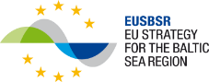
Programme for South Baltic Sea conference
“Bioeconomy – agricultural and fishery challenges for the future”
18-19 september 2018
Venue: Kalmarsalen, Skeppsbrogatan 49, 392 31 Kalmar
18 September 2018
Moderator: Sebastian Magier, ERB
11:30-12:00 | Registration at Kalmarsalen
12:00-13:00 | Lunch at Kalmarsalen
13:00-13:15 | Welcome speech  Leif Larsson, Politician, The Regional Council in Kalmar County
13:15-14:00 | Bioeconomy from an EU Strategy for the Baltic Sea Region (EUSBSR) perspective!  Hans-Olof Stålgren, Policy area coordinator in the EUSBSR (fishery),
14:00-14:30 | Bioeconomy from an EU perspective,  Adam Andersson, Småland Blekinge Halland South Sweden office in Brussels
14:30-15:00 | Coffee brake
15:00-15:30 | Panel  Adam Andersson Småland Blekinge Halland South Sweden office in Brussels, Hans-Olof Stålgren, PAC EUSBSR,  Anna Thore, WSP,  Joacim Rosenlund, Linnaeus University
15:30-15:45 | Egg-testing  Anna Thore, WSP
15:45-16:30 | Bioeconomy from a regional/local perspective.  Carolina Gunnarsson, The Regional Council in Kalmar County  Mette Jørgensen, Guldborgsund Bioøkonomisk Vækstcenter  Input also from Poland, Germany and Lithuania.
16:30-17:00 | Presentation of the South Baltic programme,  Marta Niciejewska, South Baltic Programme secretariat, Gdansk
17:00-17:30 | Presentation of the Umbrella project and how it can be used to solve the problems, Sebastian Magier and Valentina Scandola, ERB
19:00- | Dinner at Kalmar County Museum and presentation of the “Kronan exhibition”

19 September 2018
09:00-12:00 | Parallel workshops:  1/ Land based fish farming. Venue: Kalmarsalen  Moderator Kimberly Berglöf, The Regional Council in Kalmar County  Input from: Veronica Andrén, Swedish Board of Agriculture  Representative from East Regional Aquaculture Center (ERAC) http://www.vattenbrukscentrumost.se/en/ (TBC)  Johan Ljungquist, Land based fish farmer, Gårdsfisk http://www.gardsfisk.se/  Ola Öberg, Recirculating Aquaculture Systems  2/ The round goby (Neogobius melanostomus) Threat and/or resource?  In Swedish “Svartmunnad Smörbult”, in Danish: “Sortmundet Kutling”, in Polish: Babka śniadogłowa and in Lithuanian “Juodažiotis grundalas”:  Venue: Kalmarsalen  Moderator: Susanna Minnhagen, City of Kalmar  Input from:  Jane Behrens, Technical University of Denmark, National Institute of Aquatic Resources, “Sustainable use of the invasive round goby in favour for the fishery and the environment”  Gustav Hellström, Swedish University of Agricultural Sciences. “”News from the invasion front - current research and status of Round Goby in Sweden”  Ulf Grönqvist, SEAC http://seac-ab.com/, “Round Goby tests with SEAC AB fish processing machines”  Susanna Minnhagen, City of Kalmar. “Goby-snacks for school-lunch? A possibility to combine local political goals in coastal management”  Kari Stange, MSC - Marine Stewardship Council. “Network for sustainable Baltic Sea small-scale fisheries and their interest in goby-fishing”  Mette Jørgensen, Guldborgsund Bioøkonomisk Vækstcenter  3/ Use of household and agricultural waste and manure for the production of bioenergy.  Moderator: Anna Thore, WSP  Venue: More Biogas plant, Mosekrogsvägen 2. 395 97 Läckeby. http://morebiogas.se/ Transport from Kalmarssalen to More Biogas plant 8:30.  Input from: Per-Göran Sigfridsson, More Biogas,
12:00-13:00 | Lunch at Kalmarsalen

Note: The conference including lunches, coffee brakes and dinner is free of charge.

Recommended accommodation:
Calmar Stadshotell, Storgatan 14, 392 32 Kalmar (350 meters from the conference venue)
https://ligula.se/en/profilhotels/calmar-stadshotell/
Price: Single room 920 SEK
20 single rooms pre booked. Last booking day 4 September 2018
Booking: Tel nr. +46 480 496900 or e-mail: calmarstadshotell@profilhotels.se
Booking reference: “Umbrella”
Frimurarehotellet, Larmtorget 2, 392 32 Kalmar (750 meters from the conference venue)
https://www.frimurarehotellet.se/?lang=en
Price: Single room 855 SEK
Dubble room 1.055 SEK
5 single rooms and 15 double rooms pre booked. Last booking day 5 September 2018
Booking: Tel nr. +46 0480-152 30 or e-mail: info@frimurarehotellet.se
Booking reference: “Umbrella”
Travel recommendations:
From Poland:
Flight: From Gdansk to Kalmar 18/9: Flight with SAS to Kastrup 6:10-7:10, Train 8:22-11:59.
From Kalmar to Gdansk 19/9: Train to Kastrup 15:57-20:10, Flight to Gdansk 23:00-23:55
Ferry: From Gdynia to Karlskrona 17/9 21:00-07:30. Bus 6 to Bergåsa, Train to Emmaboda-Kalmar or bus 500 to Kalmar from Bergåsa. Arrival in Kalmar 10:01-11:35 .
From Kalmar 19/9 17:05-18:42. Departure from Karlskrona 21:00. Arrival in Gdynia 07:30.
From Lithuania:
Flight: From Palanga to Kalmar 18/9: Flight with SAS to Kastrup 7:00-7:05, Train 8:22-11:59.
From Kalmar to Palanga 19/9: Train to Kastrup 15:57-20:10, Flight to Palanga 22:50-00:55.
Ferry: From Klaipeda to Karlshamn 17/9 21:00-09:00. Bring your own car. Travel Karlshamn-Kalmar 2 hours.
From Kalmar 19/9. Departure from Karlshamn 19:00. Arrival in Klaipeda 09:00.
From Denmark:
With train from Nyköbing-Copenhagen 05:47-07:26, Copenhagen-Kalmar 08:07-11:59.
With train from Kalmar- Copenhagen 13:00-16:48, Nyköbing-Copenhagen 17:09-19:00.
With car from Guldborgsund to Kalmar around six hours.
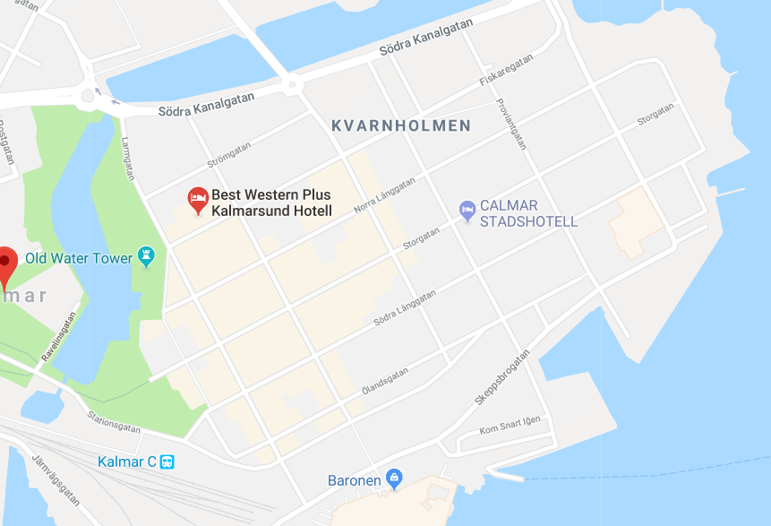
Frimurarehotellet
Kalmarsalen
Calmar stadshotell
Kalmar County Museum

