UMBRELLA 2.0

Awareness Raising event

Culture & Tourism, 27.04.2021 13:30-14:30 CEST
- Key intervention by Kaarina Williams, EUSBSR PA Culture Coordinator, BSSSC
- Intervention by local stakeholder: Nils Jacobsen, CittaSlow Sokndall, Norway
- Intervention by regional stakeholder: Magda Zakrzewska-Duda, Batic Sea Cultural Centre, Gdańsk, Pomorskie, Poland
- Moderation by: Marta Czarnecka - Gallas, BSSSC
Related to:
- EUSBSR - Policy Area Culture / Policy Area Tourism
- EU GREEN DEAL: the transformation of agricultural and rural areas / Sustainable transport
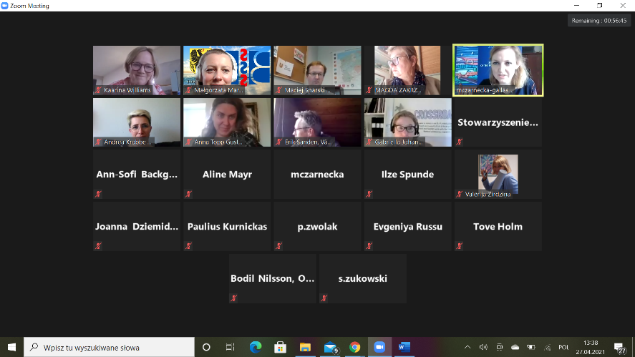
Kaarina Williams:
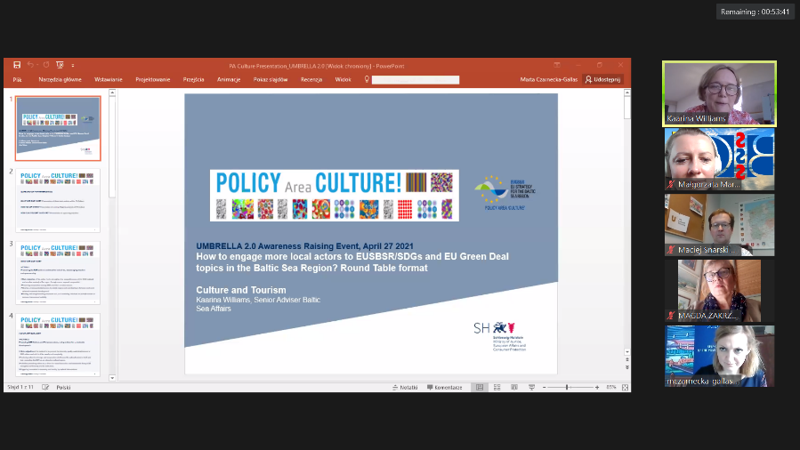
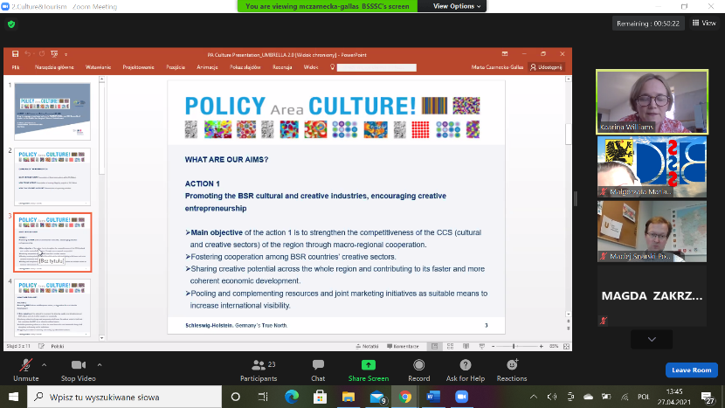
We have 3 actions:
Action one: We want to foster cooperation, we want to grow stronger and have more coherent economic sector. We want to make creative industries more visible, international in the BSR and beyond.
Action two: to present the diversity, variety and complexity of culture in BSR, culture as a driver to sustainable living
Action three: Cultural heritage and identity. We can foster and strengthen cooperation as such, cross-cutting issue. Increase value of heritage and culture, tourism. Promote public interest and access to it. Make heritage visible.
How we work: PAs are complex, but we work in this context of supporting projects and our aims. Running flagships, strive to develop and support new ones. We organise strategic projects developments workshops. Political impulses for cultural projects. We encourage youth and civil society involvement. Baltic Sea Cultural Cities and Regions – seed money project by CBSS described. Project as co-creative process to involve actors and not competing as such.
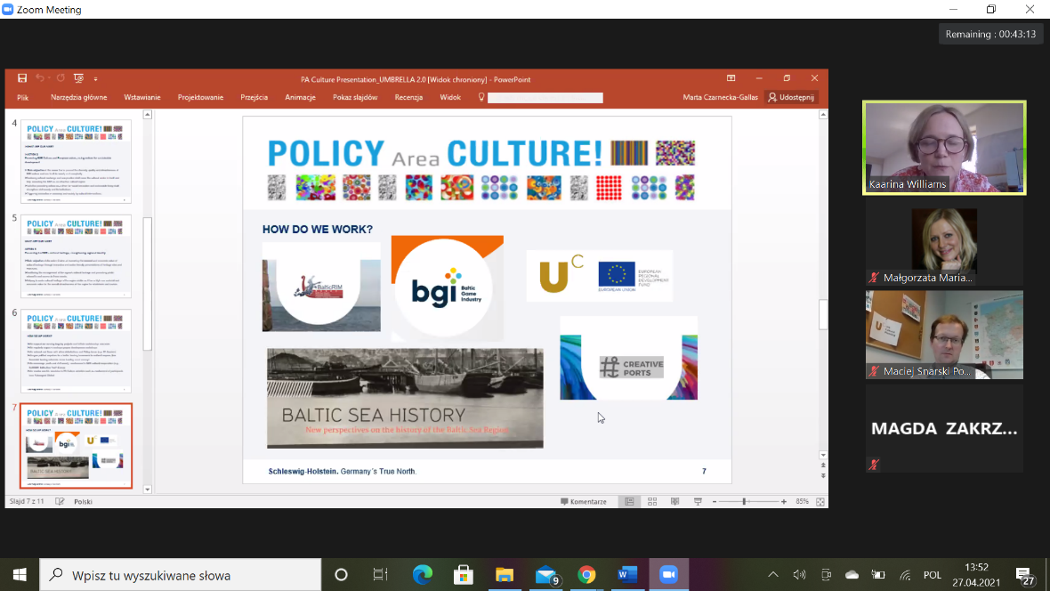
Upcoming actions: 12th and 13th Project Development PA Culture Workshops. (May and June 2021). If you are interested please join and fill out the questionnaire with your project idea, we will guide you.
I hope this presentation was helpful and please share where you see the obstacles to join and initiate projects, I am here to help and answer questions.
Marta: Thank you. Sharing the cooperation between countries (PA Culture) between Poland and Germany is the added value. We have Rafał Jewdokimow from Polish side too, who together with Kaarina will be able to answer questions. We have here also Magda Zakrzwska Duda from BSCC and URBCultural Project. She will also share her experiences with cultural initiatives.
From the chat:
- From Olga Zuin_CBSS to Everyone: 01:31 PM
https://cbss.org/psf/
- From Baiba Liepa (Interact) to Everyone: 01:31 PM
https://www.euro-access.eu/regions/eusbsr_-_baltic_sea_region
- From Tove Holm to Everyone: 01:33 PM
I also recommend this: https://www.norden.org/en/funding-opportunities
- From Rafal Jewdokimow PA Culture to Everyone: 01:59 PM
- https://9013f30f-21aa-484b-ac38-c0a8a59bf5ef.filesusr.com/ugd/79bdd7_d120e112dcda4ab8b760648bb07efe46.pdf
Official invitation to the workshop :)
Magda Zakrzewska-Duda: I am the matchmaker – I match people, ideas, projects in the BSCC as a senior specialist. Here is the website: www.urbcultural.eu. Involved in two lines: cultural policy and gamification. The roadmap and toolkit are available on the project website and translated into Polish. We will start soon the mentoring project connected to using the method on cultural planning. Please contact your local authorities and join in your countries for the upcoming meetings.
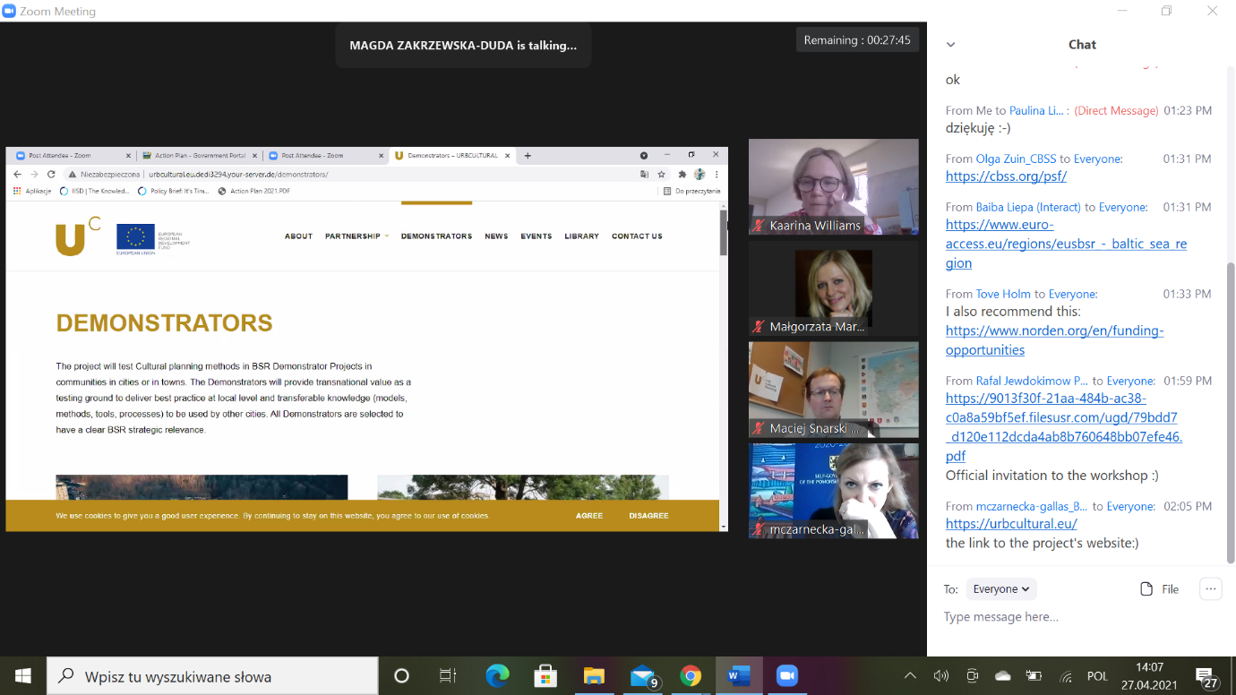
We invite you to the workshops, too. We have the www.gameofgdansk.eu is the tool how to use Minecraft as a tool in your place. As the BSCC we do a lot of projects, we joined Culturability seed money project and from this one the big project was developed and this is how we joined it. Don’t be afraid to jump in and explore new areas and events. It is an empowering experience.
Marta: Andrea had to go, so if you have any questions about tourism please leave them here and we will send them to Andrea. Here you heard also the perspective of the PA and of the project partner, so if you have any specific questions, please ask.
Chat:
- From mczarnecka-gallas_BSSSC to Everyone: 02:05 PM
https://urbcultural.eu/
the link to the project's website:)
- From Maciej Snarski Pomorskie to Everyone: 02:08 PM
https://urbantoolkit.eu/about-program/
https://en.gameofgdansk.eu/
- From Andrea Krabbe PAC Tourism to Everyone: 02:10 PM
I really Need to apologize...I have to leave the Event because of urgent issues...in case of Questions please write an email to
a.krabbe@wm.mv-regierung.de
- From Kaarina Williams to Everyone: 02:10 PM
No worries Andrea, take care :)
- From mczarnecka-gallas_BSSSC to Everyone: 02:11 PM
thank you for your participation, Andrea.
We will send you the questions if they arise:)
Marta: Any specific entry points that the newcomers could establish with you? Newcomers seek for rather small funds, not the big INTERREG. Any advices?
Kaarina: Nils entered, so I will be quick. Also smaller endevours come up and this is the reason why we have the workshops coming in May and June. If you contact us we will help you find funds, partners, information. If you have a local idea to go international, we can try to help you with this.
Marta: Thank you. Welcome Nils, please share your presentation.
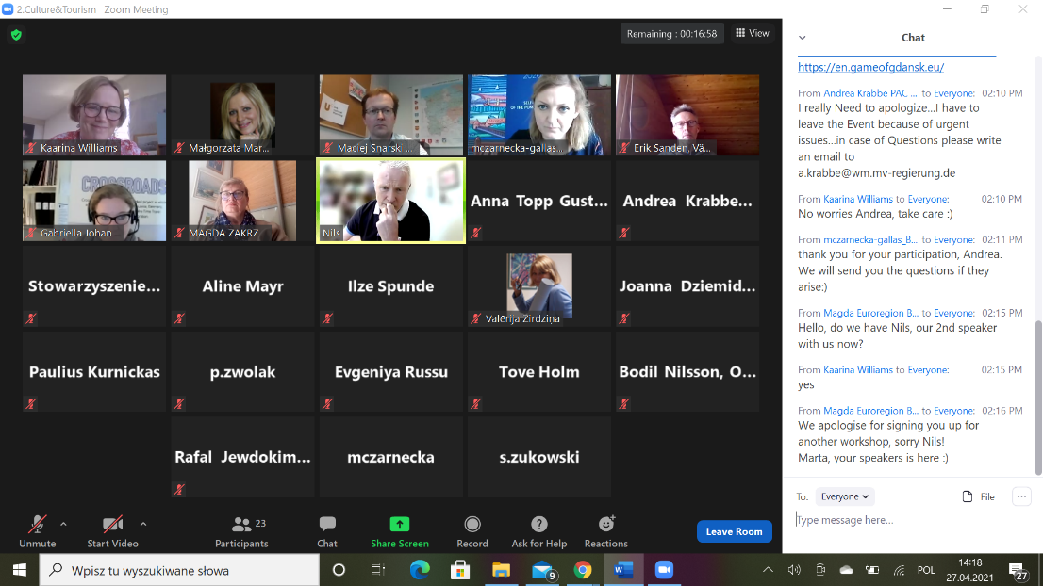
Nils: We are a small community along the coastline. 200-300 years old wooden buildings. We have old fishing boats and many hiking areas in the municipality. Lighthouse can be rented. We have old museum here and Sokna salmin river. We have lots of hiking routes. Highest mountain is 600 m above sea level. Here we have a place for youth and families in the city. We are going to build a science museum, will be completed next summer. Indoor track 5000 m2 for motors.
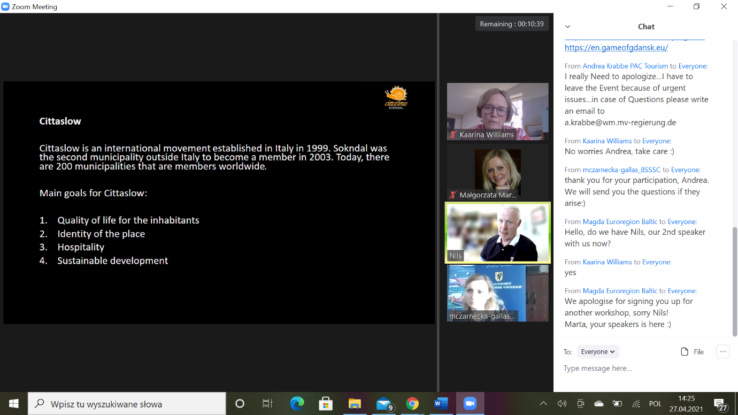
We joined Cittaslow, 200 municipalities worldwide. We will establish center for people without work to give them regular jobs.
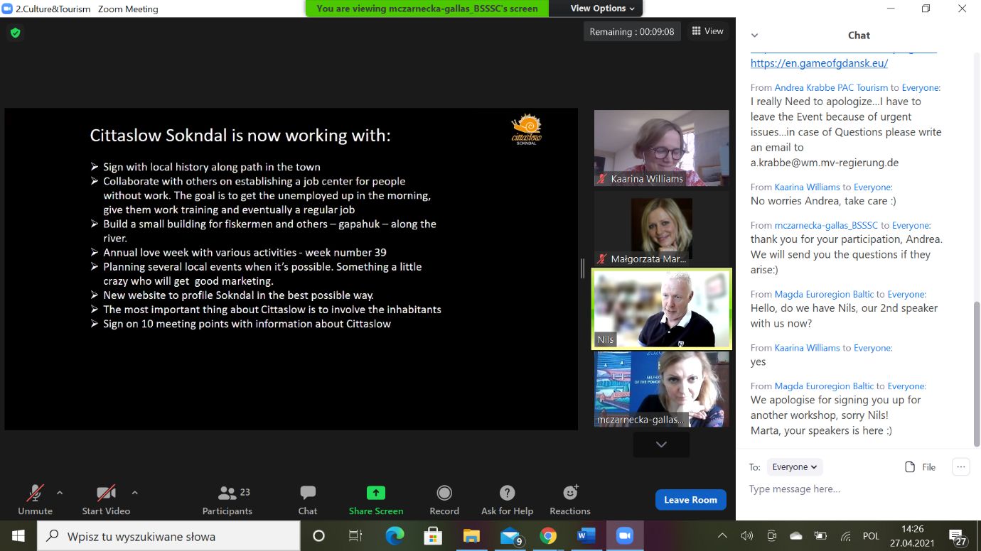
We prepare information about the city and its possibilities and share it with citizens. We organise a loving week for citizens. We integrate new citizens. We have 46 cultural and geological locations to visit. We love to be cittaslow .
Marta: Beautiful pictures and we see your passion. This is how cities work with citizens - not only for tourists, but mainly citizens which is precious. We have now only a few minutes left, are there any questions?
Maciej: Sokndal is a member of Cittaslow. Have you got any statistics covering the results of the improvements done in the municipality?
Nils: 40 000 visitors=guests but we do not know how many according to cittaslow. Not so easy to have statistics. Last year because of the pandemic the hotel said they had the best summer ever as Norwegians started to visit their own countries.
Maciej: so you seek for domestic visitors.
Nils: also from Germany and many other countries. We have no tourists, just guests, due to our attitude and Cittaslow.
Marta: are there any comments?
Kaarina: How do you meet with Cittaslow? How do you work together?
Nils: We have an annual meeting in June and working meetings, 2-3 times every year, this year on Teams. Also with the Nordic Network.
Marta: Thank you all, we have to finish now. Please stay in touch with our experts and write to organisers and we will provide you with answers. We will be soon taken to the main panel, so once again thank you for your participation and let’s stay in touch.

