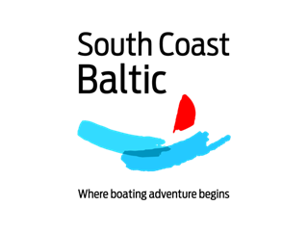


REGISTRATION FORM
Please fill in & e-mail to
sommer@invest-in-vorpommern.de
by 13 April 2017
Name:
Institution:
Phone:
E-mail:
______________________________________________________________________
I confirm my participation in the event according to the following indications:
Kick-off Conference (16 May, 09:00 - 18:00 h) YES ☐ NO ☐
Partner meeting / part 1 (17 May, 09:00 - 18:00 h) YES ☐ NO ☐
Partner meeting / part 2 (18 May, 09:00 - 18:00 h) YES ☐ NO ☐
Informal get-together (15 May, 19:30 h) YES ☐ NO ☐
Joint dinner / 16 May (16 May, 19:00 h) YES ☐ NO ☐
Joint lunch / 17 May (17 May, 12:30 h) YES ☐ NO ☐
Joint dinner / 17 May (17 May, 19:30 h) YES ☐ NO ☐
Joint lunch / 18 May (18 May, 12:30 h) YES ☐ NO ☐
______________________________________________________________________
I will travel to / from Bansin by (e.g. car / train / plane / ferry / other):

I will arrive in Bansin on (day – dd.mm.): at (time - hh:mm):
I will leave Bansin on (day – dd.mm.): at (time - hh:mm):
I would like to make some further remarks (e.g. special food, vegetarian, I leave earlier / I arrive later, need of any further assistance etc.):

I have booked a room at
Seetelhotel Kaiserstrand ☐
Other hotel ☐ (please name)
Please make your room reservation directly at the hotel by 13 April 2017.

